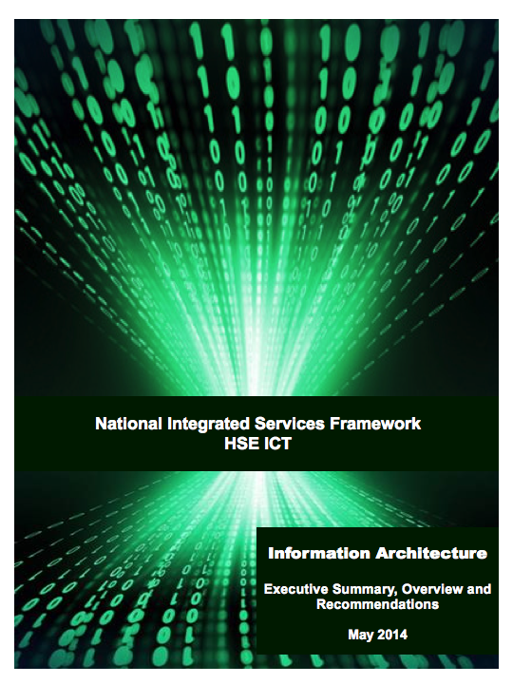



René M. Schippers, ERS B.V.
Gerard Freriks, ERS B.V.
Executive Summary, Overview
and Recommendations
version 3 - May 2014
HEALTH SERVICE EXECUTIVE
ICT National Integrated Services Framework Project

Management Summary 3

Introduction 3

PART 1: Information model requirements 3

PART 2: Data Dictionary requirements 3

PART 3: Terminology assurance requirements 3

PART 4: Support processes & services 3

Discussion 3

Project overview and recommendations 3

HSE Mini-competion: LOT 4 Information Architecture 3

Introduction to mini-tender 3

Mini-Tender Work Programme Objectives 3

Proof-of-Concept within the proposed model. 3

PARTs 1-4 3

PART 1: INFORMATION MODEL REQUIREMENTS 3

Item 1 Standards based Information Architecture Reference Model (IA-RM) 3

Item 2 The provision of a standards based subject area model (SAM) 3

Item 3 The determination which technical systems should participate in the subject area model (SAM) 3

PART 2: DATA DICTIONARY REQUIREMENTS 3

Item 1 Standards Based Data Dictionary 3

Item 2 Validation (Proof-of-Concept) of the Data Dictionary 3

Item 3 Governance Framework and Tooling for Dictionary 3

Item 4 Catalogue with the Standards and associated sub-sections for the Dictionary 3

PART 3: TERMINOLOGY ASSURANCE REQUIREMENTS 3

Item 1 Blueprint for the deployment, management and maintenance of the terminology service 3

Item 2 Validation via binding of SNOMED CT concepts to a specified clinical data set 3

Item 3 A catalogue with the Standards and linkages associated with its operation and maintenance 3

PART 4: SUPPORT PROCESSES & SERVICES 3

Item 1 Standards based toolset 3

Item 2 Products that best meet this need including commercial and open source toolsets 3

Item 3 The recommendation of an established toolset and management approach to facilitate 3

Management Summary
‘Standardisation is a fundamental requirement for truly shareable Electronic Health Records (EHRs) and the harmonious delivery of Universal Health Insurance. Equally it provides the basis for quality assured real time data collections from autonomous yet aligned institutions.
With an expanding national healthcare asset profile of around €1bn in ICT technologies including 1,700 applications, a standards based roadmap offers both an essential tool and an internationally established method of best practice for ensuring system alignment and strategic management of the HSE’s ICT portfolio.’

European dimensions will have an increased influence on National eHealth because of European projects such as epSOS (Cross border Patient Summary and Prescription), the need for National Contact Points and the European Directive on the application of patients’ rights in cross-border healthcare and the ‘Guidelines on minimum and non-exhaustive patient summary for electronic exchange in accordance with the Directive 2011/24/EU release 1’ .
The epSOS test infrastructure that is based on HL7v3 R2 CDA / IHE-profiles,will be dissolved by July 1st 2014. All epSOS profiles and implementation guides will be handed over for archiving to the Connecting Europe Facility (CEF). A number of Member States want a new requirements driven design of the epSOS architecture.
In the European context for cross-border data exchange requires the establishment of a standards based National Contact Point. This will make provision for the exchange of priority citizens data such as: patient summary, e-prescriptions and e-referrals plus e-discharge.
The eHealth Strategy for Ireland as published in 2013 positions the Irish National ICT Integrated Services Framework (ISF) as an integral part, to leverage existing investments wherever possible and overcome the current collection of ‘data silo’s.

‘The Irish ISF is an Interoperability Framework offering a shared standard’s based tool and language for defining and aligning the business and interoperability context for Ireland’s eHealth systems. Most importantly, it provides a services architecture which is independent of technology. eHealth does not only apply to a healthcare organisation in isolation but also to the exchange of clinical information on an industry-wide basis. The ISF will enable the HSE to overcome data silos and facilitate systems and services to grow in an aligned and evolutionary manner. The ISF embraces all of the core ICT systems, technologies and associated business processes. It aligns with mandatory national and European standards and associated initiatives including requirements for record portability across jurisdictional boundaries.’

The Information Architecture Viewpoint and its constituent components as outlined in this document provide the central reference point and structure for the realisation of this eHealth ecosystem and a National EHR.
The proposed Information Architecture Reference Model (IA-RM) provides the capability to the HSE and related agencies to scale in fast and agile manner the development and roll-out of interoperability solutions using a single shared guidance framework.
The standards based information model articulated in this document has been validated and quality assured by an International centre of excellence (NHS HSCIC) to provide the highest level of independent validation possible.
The proof of concept as demonstrated by ERS B.V. provides the foundational component that Ireland may wish to develop further when architecting a National Contact Point based on the epSOS European data set that will serve as an internal and external broker. eHealth Ireland may wish to leverage the outputs of the proof of concept including the establish a Date Utility Platform including National Data Dictionary functionalities.

Introduction
HSE issued a second stage mini-tender (HSE Tender Reference: Project 2550) for LOT 4-Information Architecture of the National Integrated Services Framework (ISF) project. Since September 2013 ERS is executing the resulting project.
The following parts were defined that were to be addressed: Information Reference Architecture, Subject Area Models, Data Dictionary, Coding systems and Governance.
The tender document pointed at the Memorandum of Understanding between the NHS-England and HSE Ireland to be used by ERS.

PART 1: Information model requirements
Based on the ERS’ findings, including this MoU, desktop research, workshops and an enquiry among HSE defined stakeholders, we conclude that the roll-out of the Integrated Services Framework based on the result of LOT 4 will be effective.
ERS conducted a questionnaire, nine workshops and many discussions with health-IT actors. That enforced our opinion about the state-of-the-art in Ireland and the way forward.
An Information Architecture Reference Model (IA-RM) is proposed based on the CEN/ISO EN13606 standard. This IA-RM supports healthcare actors to define their data needs in data sets. Archetypes and Templates represent these data sets in human readable and computer readable formats. Formats that support validation by healthcare actors and swift flexible implementations in IT-systems. These formats can be used in procurements.
The approach taken by ERS as developed for HSE is supported by developments and deployments in National projects of England and Spain. England deploys the ISO 13606 standard in its Information Architecture to produce HL7v2 messages and HL7 v3 CDA documents that can be used in the IHE environment.
The approach taken by ERS is in alignment with requirements mentioned in the first stage tender National Framework Agreement ICT Integrated Services Health Service Executive HSE Ref 114 / 12.
ERS’ approach is supporting a Service Oriented Architecture (SOA) specification for the coupling of data repositories and services with platforms and applications. ERS’ approach facilitates the integration of disparate existing IT-systems.
The approach taken by ERS produces a specification for mapping systems and services (EAI) that act as the go-between or broker between the multiple source applications and the EHR framework. It makes possible for HSE to identify any databases that may require joining (adaptors) to facilitate completeness of the data architecture.
Further it will be possible to build an architectural specification that will underpin a model that will have a web based orientation and use multiple implementation platforms. The architectural specification supports a standards based SOA architecture that encompasses an Enterprise Service Bus (ESB) and Enterprise Application Integration (EAI) components.
ERS work on LOT 4 is executed from the perspective that a suggested way forward should facilitate an evolutionary process of change and should make it possible to use existing messaging solutions as used by HealthLink. This makes it possible to leverage existing investments.
As part of the IA-RM Subject Area Models (SAM’s) are documents that represent the data sets. From these SAM’s output in various formats can be generated.
ERS delivered specific EHR related knowledge and expertise to help define the library of semantic interoperability artefacts that are used in the context of the EHR and the exchange and re-use of data. The library must support the provision of care and the administrative reporting needs. The semantic artefacts describe the information needs in a way that is understandable for the health actors (users) and is computer processable by the IT-industry at the same time. Exemplar Semantic Interoperability artefacts are provided with codes from designated reference coding systems but local codes can be added to it; thereby a mapping of local to international reference coding systems will be documented. The epSOS Patient Summary is chosen as exemplar because of the EU Directive 2011/24/EU which Ireland needs to comply with and because of the overlap with HIQA work on the discharge summary.
ERS used a normalised method to create semantic interoperability artefacts. Artefacts that can be used in conjunction with HL7v2, HL7v3, HL7v3 R2 CDA data exchange formats and other formats.
The library of semantic artefacts supports the storage, smart retrieval, publication, and quality assurance using various techniques, among other ontological ones. A governing organisation for these libraries is necessary.

PART 2: Data Dictionary requirements
A Data Dictionary is resource where data fields in a data base or message are defined.
Based on desktop research, demonstrations of our own software functionality of the ISO 11179 standard was researched. ERS concludes that when SAM’s are produced using the CEN/ISO EN13606 standard all requirements of the Data Dictionary are met. EN ISO 13606 Archetypes and Templates allow a more detailed expression of data sets /SAM’s.
Several commercial products were inspected.

PART 3: Terminology assurance requirements
Coding systems are needed to give a precise and interoperable meaning to concepts that are used inside all CEN/ISO EN13606 Templates and Archetypes.
Coding systems are needed for: Clinical terms, persons (unique identifiers for patients, healthcare providers and their organisations, devices, medicinal products. These coding systems need to be licensed. Examples of indispensable coding systems are: SNOMED-CT, LOINC, ICD-x.
A Terminology Server is a service that helps deploy codes and sets of codes.
ERS demonstrated the epSOS data set transposed in to CEN/ISO EN13606 Template and Archetype including the use of one specific Terminology Service to attach SNOMED-CT and LOINC codes to the epSOS Patient Summary SAM.
Possibly these coding systems need Ireland specific extensions and an organisation for the governance.

PART 4: Support processes & services
Data sets, SAM’s and all their output formats, the coding systems need an IT-environment for the creation, publication and maintenance of all semantic interoperability artefacts.
The ISO 13119 – Health Informatics: Clinical knowledge resources - Metadata standard is developed to describe all meta data about semantic interoperability artefacts / documents. Two products based on this standard exist and that create a collaborative environment for the handling of the various related documents and that supports the jointly develop and validate the SAM’s and its code sets.
One organisation for the governance is needed.

Discussion
ERS approach is in alignment (± 90%) with the wishes expressed by Stakeholders in feedback sessions and a questionnaire used to structure the feedback. Next to the leveraging of existing solutions and infrastructures it is stressed by Stakeholders to take steps as described in our Recommendations. To get rid of thick implementation guides, make a first step towards seamless integration of data and have a real time overview on processes performance for steering purposes and be able to use data captured in silos for clinical research and population research and re-use in general. The cost of message based integration by a managed process can be shattered using the EN ISO 13606 standard for integration of systems. This brings the EHR, as desired by HSE, closer to reality. Even today’s delivery process of HSE new solutions triggers huge amortisation cost of existing systems and triggers huge integration cost, because message standards of new to be deployed systems are not supported by the existing system that will be replaced. The costs of the building of one EN13606 Connector / Interface, which is supportive to each single integration requirement is comparable with the implementation costs of a single HL7v3 R2 CDA message based integration.
Next to patient safety the leveraging of existing investments is one of the reason why the ISF project was started.
Countries like England (NHS-HSCIC) and Spain (Ministry of Health), but also the Clinical Information Modeling Initiative (with among others members like the US DoD, InterMountain, and Mayo Clinics), have taken the decision to use the CEN/ISO EN13606 (or a profile thereof) for the creation of Archetypes and Templates, that express the data needs of healthcare.
Recommendation
Decide to adopt for use in Ireland the proposed Information Architecture Reference Model and creation of Subject Area Models as input for procurements for Irish health IT_systems, while taking in to consideration the substantial consensus as the result of the questionnaire, the workshops and specifically the final workshop with the industry.

Project overview and recommendations

HSE Mini-competion: LOT 4 Information Architecture
Mid 2013 the HSE publishes the” Invitation to tender document, mini-competition, ICT Integrated services Framework, LOT 4 Information Architecture, provision of specialist standards services for the HSE”. HSE Tender Reference: Project 2550.

Introduction to mini-tender

‘Standardisation is a fundamental requirement for truly shareable Electronic Health Records (EHRs) and the harmonious delivery of Universal Health Insurance. Equally it provides the basis for quality assured real time data collections from autonomous yet aligned institutions.
With an expanding national healthcare asset profile of around €1bn in ICT technologies including 1,700 applications, a standards based roadmap offers both an essential tool and an internationally established method of best practice for ensuring system alignment and strategic management of the HSE’s ICT portfolio.
In recognition of this need, and based on international best practice the HSE’s ICT National Integrated Services Framework (ISF) project has been established to develop a practical standards based framework for applications, information, communications and technical architectures. This standards based framework will define the environment in which we design, develop and acquire systems in the future.
This is a CMOD (Dept. of Finance) approved project, and when complete the framework will ensure that the manner in which we deliver ICT solutions is aligned with the overall national strategy and business objectives. Implemented correctly, the framework will ensure that the required levels of integration between systems are achievable.
Upon commencement of the project a review was undertaken of global best practice including solution demonstrations and site visits. It was quickly recognised that HSE ICT needs to ensure the adoption of a holistic and yet pragmatic step-wise approach to the establishment of the framework.
This approach requires the early establishment of a standards based reference model incorporating a shared Data Dictionary and a suitable terminology such as SNOMED CT. The purpose of this mini-tender is to determine at a conceptual and partly functional level the structural components and relationships required within the model.
The data model resulting from this mini-tender process will be used to provide a referential basis for the alignment of our ICT systems, specifically for improved semantic and syntactical interoperability and to lay the foundation for a standards based Information Architecture.
The deliverables outlined herein also have a number of practical elements to ensure future viability and to facilitate planning for broader implementation and scalability.
Aside from clear cut technical benefits, the deliverables will be shared with all stakeholders as it will facilitate enhanced data collections, improved data quality and act as a catalyst for business model improvements, as per LOT-3 of the original tender.’

Mini-Tender Work Programme Objectives
‘The overarching purpose of the work components in this mini-tender are to provide a ‘standards based blueprint’ for the Data Model for the future support our users and technology base.
The immediate objective is to determine both what, and how, data should be shared across multiple applications within the HSE and where appropriate its partner agencies. The objective is also to determine how the data is to be shared and managed at a systems level.
It does not seek to determine how data will be used within the business domain, but rather to provide a core referential model that is standards conformant and facilitates semantic and syntactical computability across our platforms and technologies.
The outputs of this endeavour (data model) will be made available to the business user community for evaluation and extrapolation to their individual requirements. As is the international experience, the model will undoubtedly require future modifications and extensions over time to meet such needs.
The model must also be quality assured to validate its capability and suitability within the current technology and user setting. This will require the standardisation and structuring of one or more sample datasets and their practical validation.’

Proof-of-Concept within the proposed model.
‘A central component of the model will be the Data Dictionary. It will be necessary to determine the structure and content of the dictionary including where and how the properties, associations, and constraints of content should be defined.
A key principle underpinning our approach is the need to leverage the potential afforded in existing (core) technologies and to ensure they are part of the model. Some of these already have integrated bespoke dictionaries and datasets.
With regard to implementation and advancement of the model consideration should be given to the fact that the desired approach is one of gradual incremental migration toward the end goal of a truly interoperable healthcare data model and information architecture.
Further work will be required to refine the model and bend it to immediate stakeholder needs. This in turn will lead to an increased level of practical application of the model.
A governance group is currently under consideration for the broader use of the emergent data model. Its establishment is unlikely to have a direct impact on this phase of work. However, the outputs of this work package will be considered by the new governance group with regard to the adoption and use of the model by business stakeholders. Accordingly, whilst the deliverables will be technical in nature the overriding narrative or executive summary from this work should be interpretable by a business user audience.’

PARTs 1-4

PART 1: INFORMATION MODEL REQUIREMENTS
Part-1 Determination of the Information Architecture Reference Model
- The establishment of a suitable standards based Information Architecture Reference Model (IA-RM)
- The provision of a standards based subject area model (SAM)
The determination of which technical systems should participate in the subject area model (SAM)
- Recommendation of a Governance Framework and Tooling for Model maintenance and expansion
- A catalogue with the Standards and associated sub-sections for the Model

Item 1 Standards based Information Architecture Reference Model (IA-RM)
The establishment of a suitable standards based Information Architecture Reference Model (IA-RM).

‘Currently no ‘ICT Standards’ based reference model exists for the HSE’s information architecture. From the outset, the project board has considered this as being an essential structural component and have also deemed it a critical starting point.
The requirement is for the specification of a ‘standards based’, overarching Information Architecture model which takes consideration of existing and planned business activity. It will be used a referential tool to define, explain and provide oversight for data requirements and structures with key stakeholders before final endorsement.
The model should give consideration to the ‘Standards Based’ foundational requirements for semantic and syntactical interoperability of Health ICT Systems across a TRUST based structure. The model should define the necessary foundational components required for assured Data Collections and a future ‘standards assured’ National EHR.
Within an international context it is noted that partial examples of this model exist within Healthcare ICT, for example high level expressions of the NHS Logical Record Architecture, as well as the Canadian Infoway and Singapore Information Architecture Models. Our requirement in this section is simply for a conceptual model which may be easily articulated by suppressing heavy technical detail and ideally only contain clearly defined ‘standards based’ elements related to a high level holistic overview of the architecture.
It should also be noted that other partner agencies have also agreed to provide comments and guidance to the successful parties. These include NSAI, HIQA and Academia.’

Findings

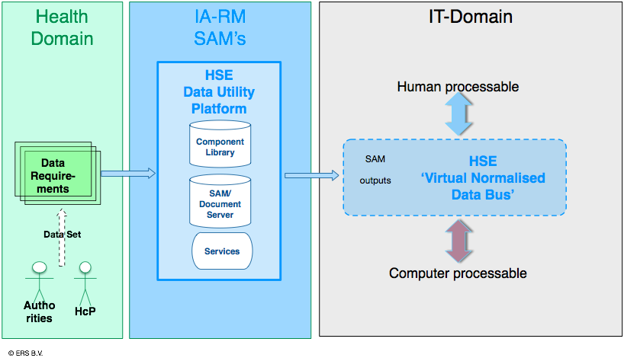
The desktop research, requirements, workshops and questionnaire led to the proposed Information Architecture Reference Model.
Healthcare providers and agencies can define Data Sets that are transformed into Subject Area Models. The HSE Data Utility Platform consists of a SAM-Editor, a collection of re-usable components to create SAM’s, and a Document server for all SAM’s, access to Terminology Servers, the component library and collaboration, publication and governance tooling.
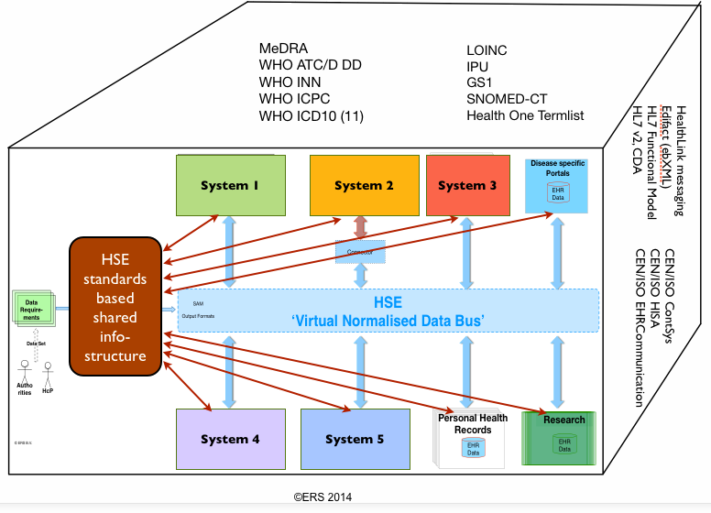
The HSE Data Utility Platform with its Subject Area Models can create an application/services ecosystem of IT-systems that exchange data.
Output of the HSE Data Utility Platform is a variety of kinds of documents serving the need of healthcare providers and agencies on one hand and a set of technical output formats that can be used by the IT-community. The outputs can be used in a procurement process.
Aligned with the HSE Data Utility Platform a ‘Virtual Normalised Data Bus’ should be created. This Data Bus allows exchange of EN13606 normalised data between systems. IT-systems that internally use other exchange standards can be equipped with a Connector / Interface that maps data from the proprietary format to and from the Normalised EN13606 Data Format.
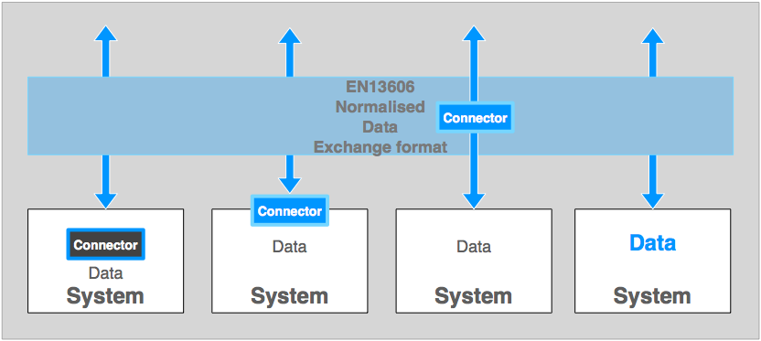
Any connector can be deployed in several ways:
- Internally part of an EHR-system.
- Inside an organisation but outside the EHR-system.
- As a provided service outside the organisation.
- Increasingly systems will be placed on the market that can deal with CEN/ISO EN13606 Archetypes and Templates and will not need a connector.
The proposed Information Architecture Reference Model creates a green level playing field for all IT-system.

Decision tree used for IA-RM standard selection
According to the tender requirements it is obligatory to base the Information Architecture Reference Model (IA-RM, SAM, and Tooling) on an open International (CEN/ISO) Standard.
This results in a short list of relevant standards to consider: HL7v2.x. for messaging, HL7v3 CDA R2 for documents and ISO13606 for EHR-communication, plus SNOMED-CT and LOINC as examples of coding systems.
In the past several organisations have analysed EHR solutions. Relevant Irish examples are two reports published by DIT and HIQA.
The DIT EHRland report describes the values of the EN ISO 13606 standard but points at issues that can be improved. Many of these issues are being addressed in the presently ongoing renewal in CEN and ISO.
The HIQA report lists various options for relevant Interoperability standards. HL7 messages, CDA, EN ISO 13606 plus the coding systems SNOMED-CT, ICD-10 and LOINC are described and analysed. It is observed that HL7 v2, HL7 v3 and HL7 v3 CDA get much traction in various countries in the world. It can be observed that since then substantial developments have taken place.
The Ministry for Health in Spain, the NHS-England (HSCIC), the Clinical Information Modeling Initiative (CIMI consisting of among others: InterMountain, Kaiser Permanente, Veterans Administration, Mayo Clinics and the NHS) have selected CEN/ISO (or a subset there of) for their Information Architecture and tooling arrangements.
As an example one slide produced by the NHS is inserted.
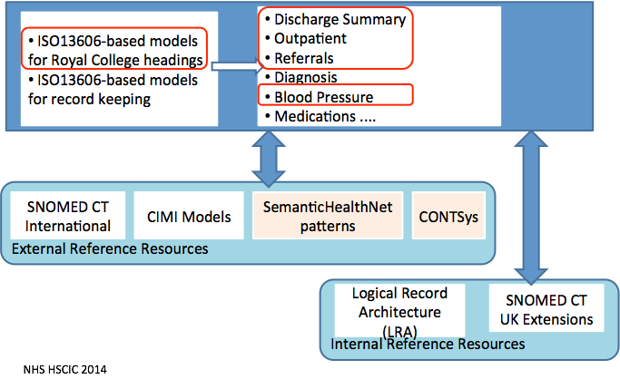
Based on the statements made in the mini-tender introduction text, objectives presented, the need for a proof of concept and the outline of the requirements the following decision tree is used to facilitate the work in LOT 4.
The next table is the result of the workshops, discussions and the questionnaire.
 | Open Standard | RM/ODP  Viewpoint | Scope EHR | Implementation  Maintenance cost
HL7 v2 messages | + | - | - | -
HL7 v3 messages | + | - | - | -
HL7 v3 CDA documents | + | - | ± | -
EN ISO 13606 EHR Communication | + | + | + | +
The next table provides the rationale leading to the selection of the EN ISO 13606 as the standard for the HSE ISF Information Architecture Reference Model.

Criteria | Justification
Open  International standards | All listed possible standards are open international standards.  Alternatives that were not listed are:  HL7 FHIR fails the criterium because it is not a formal CEN and ISO standard.  OpenEHR fails the criterium because it is a proprietary specification that shares the Two-Level-Modelling approach with the CEN/ISO EN13606 (with a different Reference Model ,Archetype Object Model and Data Types). OpenEHR is not a formal open international standard.
Scope is to create a library of re-usable structures (SAM’s) that fit the RM/ODP Information Viewpoint only | The RM/ODP standard defines 5 Viewpoints: Enterprise, Information, Computation, Engineering and Technology.  Message standards and CDA do not restrict themselves to the Information Viewpoint. They extend into the Engineering Viewpoint.  The CEN/ISO EN13606 EHR communication standard restricts its scope to the Information Viewpoint. Archetypes and Templates produced express the data sets, data requirements in a human and computer processable way.
Scope is EHR communication | Message standards like HL7 v2, HL7 v3 and the HL7 v3 CDA document standard fail this criterium since they do not have a full scope to transport data between EHR-systems. The HL7 message standards have a restricted scope of exchange between components of hospital IT-systems .The scope of HLv3 CDA is wider but is not covering the complete EHR, since the document structure of HL7 v3 CDA is a subset of the structure as defined by the CEN/ISO EN13606-standard.
Implementation and Maintenance cost | HL7 v2 and v3 messages and HL7 v3 CDA documents share the same necessary implementation process when they are deployed. First IHE profiles of these standards are produced such that they represent the local use cases. Hereafter in the second phase all vendors that claim compliance need to be tested in IHE Connectathons. Considerable resources (time and funds) are needed for both steps. Any change in the standard or the profiles necessitate to follow all steps again.  EN ISO 13606 EHR communication standard allows an agile, flexible, process because of the Two Level Modelling Paradigm that is used. A Model Driven local deployment. using predefined re-usable components (archetypes/templates), is possible. specified by the CEN/ISO EN1360

Recommendation
Decide to create an Irish standards based Information Architecture Reference Model using the EN ISO 13606 EHR communication standard to express the data requirements using Subject Area Models (SAM’s).

Item 2 The provision of a standards based subject area model (SAM)
‘The determination and provision of a ‘standards based’ subject area data model which draws on the IA-RM model above and will be used to inform major information system structuring decisions, and to define the structure and integration of future ICT systems at the data level.’

Findings
ERS build on the results as described under Item 1. The EU-epSOS project for Cross Boarder exchange of patient data was used as exemplar. A SAM was created by means of a CEN/ISO EN13606 Template consisting of multiple archetypes (subcomponents). ERS has demonstrated the epSOS SAM and the possible outputs that can be generated:
Tree view in the editor
- Mock-up functional screen
- Excel spreadsheet
- ADL1.4 Exchange format
- XML Schematron
- XML Data Instantiation
Some of these output formats can be used by healthcare actors for design an validation of the SAM’s.
Other formats are used by technical experts in the design of IT-systems, the creation of Connectors for data exchange and in procurement processes.
Data Sets that represent the data requirements of the users are transformed into Subject Area Models. (SAM’s) SAM’s are semantic interoperability artefacts that can be used by the health care and administrative domains and the IT-domain. SAM’s are build using standardised components that are re-used, thereby providing consistency between the SAM’s. The SAM and its outputs can be used in procurement.
SAM’s are created using CEN/ISO13606 Templates. The re-usable components are standardised CEN/ISO13606 Archetypes with relevant bindings to coding systems.
The HSE Data Utility Platform stores the Archetypes and Templates (SAM’s) for validation, governance, maintenance, publication, mappings that support Connectors / Interfaces used in data exchange, and used in procurement of new IT-systems.
In Spain, England, and CIMI Subject Area Models are produced using technology based on the CEN/ISO13606 standard.

Recommendations
Produce SAM’s (as CEN/ISO13606 Templates) expressing data needs by the healthcare providers and agencies, using an Archetype Library with re-usable components.
Generate output formats that present the SAM’s for inspection and validation by humans and processing by IT-vendors.
Start with the integration of Irish Registries using ISO13606 using SAM’s and a ‘of the Shelf’ Connector using the HSE Data Utility Platform.

Item 3 The determination which technical systems should participate in the subject area model (SAM)
‘Consideration must be given to the fact that a number of core systems must be able to conform to the SAM without unviable demands being placed on these systems and their interfaces. To validate the proposed model it will be necessary to identify these systems and verify the viability of their integration within the overall model.’

Findings

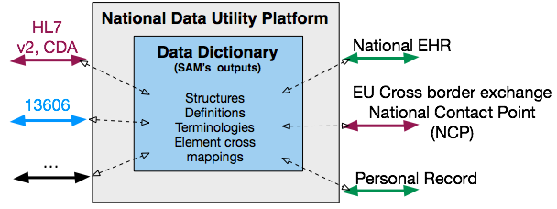
The CEN/ISO13606 standard is designed to accommodate the transfer of complex patient data form any EHR to any EHR including Registries. Tools exist that can transform proprietary data into any other format. The modelling paradigm (Two-Level-Modelling) that is used in the standard enables this versatile deployment. Model 1: the 13606 Reference Model and model 2: the Archetype Model.
A standards based suitable CEN/ISO13606 Archetype editor is available.
Proprietary EHR-systems that make use of other standards for communication can view, inspect, comment the SAM’s and can use the technical output formats in the deployment of the HSE ISF SAM’s and generated artefacts.
Human readable outputs at this moment are: Tree views, Graphical MindMaps, Excel spreadsheets (that can be input for any data base), generated mock-up screens.
Technical outputs at this moment are: ADL 1.4 files, XML files, Schematron, XML data instantiations.
The SAM technical outputs can play a role in a Connector / Interface that allows system with proprietary data formats to exchange data. Based on experiences by HSE and ERS it can be concluded that implementation costs occurred by vendors for a generic Connector / Interface based on EN ISO 13606 are the same as for one HL7v2.x message, only. Operational cost are reduced because of the possibility for a, effective and efficient Model Driven implementation of the Connector / Interface.
One of the specific connectors is for the cross-border exchange of the epSOS data sets. For this purpose a National Contact Point is necessary to take part in European developments.

Recommendations
Decide to deploy CEN/ISO EN13606 conformant Connectors (interfaces).
Decide to create CEN/ISO EN13606 Templates needed for the integration of all existing HL7v2 and HL7v3 CDA artefacts.
Decide to establish an Irish National Contact Point (NCP) to take part in European Cross border exchange of patient data and be compliant with EU-legal developments.

Item 4 Governance Framework and Tooling
Recommendation of a Governance Framework and Tooling for Model maintenance and expansion
‘It is necessary to establish an appropriate toolset and convention for the data model which will provide for quality assurance and ease of use. The Governance and Maintenance arrangements must provide capability for two audiences, firstly for those responsible for the data architecture and secondly the business users for whom the data model is being developed.’

Findings
Data set documents are transformed into SAM documents that make use of CEN/ISO13606 Archetypes.
The archetypes are selected from a library of predefined and re-usable standardised components.
Data sets, SAM’s (templates), Archetypes and all generated outputs are computer files (documents).
All documents have a document life cycle and need to be created, validated/reviewed, sometimes tested, published, maintained, exchange, deprecated and removed. This implies a need for a Governance organisation.
The steps of the product life cycle will be facilitated by health informaticians. Health informaticians are experts in understanding healthcare concepts. The health informaticians have experience with SAM production, and the archetype editor. Most often they can be Health-IT trained nurses. Observe that no IT-specialists are necessary.
Outputs of the HSE Data Utility Platform will be used by the IT-experts.

SAM’s (CEN/ISO EN13606 Templates and Archetypes can play an important role because they are used in the Connector / Interface in the mapping and data transformation process. Thereby reducing the resources needed for the creation and maintenance of the data exchange interfaces.
A set of quality requirements during the document lifecycle for the documents and organisational processed need to be in place.
The clinical content needs to be validated by healthcare providers and agencies via inspection. The technical artefacts, including implementations in IT-systems need to be tested. Because of its design CEN/ISO EN13606 artefacts always are conformant to several models. This conformance can be tested using specific parsers. IT-systems can be tested by means of a Test EHR-server with a CEN/ISO EN13606 Connector / Interface that the IT-industry can use for testing. One Nationally active organisation can provide a Test Centre for Semantic Interoperability artefacts and software.

Spain, the UK, CIMI and several EU-projects work (or have worked) on quality criteria, quality management systems, testing/validation, certification/qualification, and published about it (e.g. EU-projects: EuroRec, SemanticHealthNet, ANTILOPE, EXPAND, and CIMI.
Relevant standards are:
- EN ISO 13485:2012 Medical devices Quality management systems
- EN ISO/IEC 17011:2004, Conformity assessment – General requirements for accreditation
- EN ISO/IEC 17020:2012. Conformity assessment – Requirements for the operation
- CEN/ISO EN 13606 EHR Communication - part 2
- ISO 18308 Requirements for EHR Architectures

Recommendations
Adopt available CEN/ISO standards for quality systems, testing/certification, requirements for EHR-system architectures, etc.
Decide to establish a National Test Centre for testing of semantic interoperability artefacts and implementations.
Appoint/create an organisation responsible for the governance of HSE ISF HSE Tooling Utility Platform and its output and organisation work processes.

Item 5 A catalogue with the Standards and associated sub-sections for the Model
‘The provision of a list of the data standards applicable in part or entirety to the model, along with a brief explanatory script or blueprint to provide appropriate guidance to the user in a readily understood manner. Where possible, any relationships with other standards already recommended in parallel workstreams should also be noted.’

Findings
ERS has conducted workshops and a questionnaire. One of the topics was the standards used in Ireland.
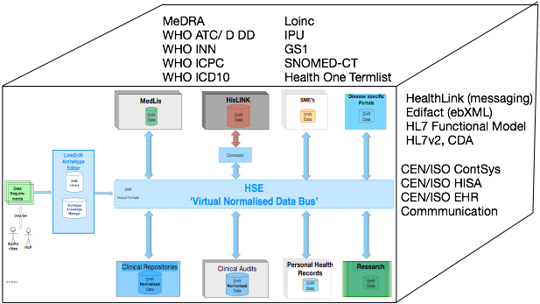
A multitude of different kinds of standards were mentioned:
- HL7
- Edifact
- SNOMED
- ICD,x
- ICPC
- IPU
- LOINC
- MedDRA
- GS1
- …
Recommendations
Maintain the list of standards as part of the HSE Tooling Utility Platform and other referenced materials used inside the HSE ISF.
Actively support and contribute to the standards on the list when needed.

PART 2: DATA DICTIONARY REQUIREMENTS
- The determination of a Standards Based Data Dictionary including the specification of meta data structure, data classes, entities and attributes
- Validation (Proof-of-Concept) of the Data Dictionary
- Recommendation of a Governance Framework and Tooling for Dictionary maintenance and expansion
- A catalogue with the Standards and associated sub-sections for the Dictionary

Item 1 Standards Based Data Dictionary
The determination o f a Standards Based Data Dictionary including the specification of meta data structure, data classes, entities and attributes.
‘Specification of a Standards Based structure for the HSE’s Master Data Dictionary, including provisions for integrity of meaning, relationships to other data, origin, usage, and format. Content for the data dictionary will include both clinical and related data items. When commissioned the data dictionary will have associations with data sets and other reference sources including terminologies and classifications. The data dictionary may be based upon a commercial, open source, or alternative national platform. However, it must be architected upon a ‘standards based’ structure.’

Findings
A Data Dictionary is a detailed description in a tabular format or database of a data set as provided by users.
ERS explored the Data Dictionary and possible standard based software solutions. The conclusion is that all ISO 11179 Data Dictionaries cover a great deal of the requirements, but missed some detailed, but essential ones. Data Dictionaries are primarily used in the process of mapping data elements in one data base to an other. In EHR-systems not only individual database elements are important but also many others that describe the full context. Not only the data element but also structural aspects like constraints are important. Data Dictionaries can describe these constraint in the annotation text but not in a computer processable way. In general passive Data Dictionaries generate human readable outputs but do not generate computer processable outputs.
ERS has demonstrated an ISO 11179 based Data Dictionary and filled it with the epSOS Patient summary. A special 13606 input module was created by ERS for this purpose.
The selected CEN/ISO EN13606 standard allows the generation of highly detailed outputs for human IT-system processing. It facilitates the deployment of data sets and corresponding Subject Area Models.
All documents that define and support the SAM’s need to be managed as semantic interoperability resources. ERS has demonstrated one such product that can manage all artefacts, their documentation, supporting guidance materials, including mappings to existing message formats.
The HSCIC of the NHS England has taken the same approach and deploys a document management service based on ISO13119 Clinical Knowledge Resources - Metadata with extensions to that model.
Recommendations
Deploy CEN/ISO EN13606 Templates and Archetypes as a more descriptive and usable alternative, instead of an ISO 11179 standard Data Dictionary.
Deploy a Document Management service as demonstrated as part of the HSE Tooling Utility Platform to manage all SAM’s and constituting standardised components.

Item 2 Validation (Proof-of-Concept) of the Data Dictionary
‘Demonstration of the standards based structure and functionality of the Data Dictionary. A number of clinical data sets can be made available for this purpose and if successful the prototype may be formalised and applied for full stakeholder usage. The proposed dataset(s) will contain no more than one hundred items.’

Findings
ERS made available an ISO 11179 standard conformant commercially available Data Dictionary and software to input CEN/ISO EN13606 Template and Archetypes into the standard based Data Dictionary. The facts as named in the previous chapter were confirmed. The expressiveness is less than EN13606 Templates and Archetypes allow to be expressed.
The epSOS data set was made available as a CEN/ISO Template (Subject Area Model) and all constituting Archetypes plus as much as possible available SNOMED-CT and LOINC codes.
Recommendations
Decide to focus on the patient characteristics (demographics) and the unique patient, healthcare providers identifiers.
Decide to use the epSOS patient summary data set as first filling of the collection of Subject Area Models (templates and archetypes) the HSE Tooling Utility Platform.
Decide to extend the epSOS patient Summary to include the HIQA patient discharge and referral data sets.

Item 3 Governance Framework and Tooling for Dictionary
Recommendation of a Governance Framework and Tooling for Dictionary maintenance and expansion.

‘This requires the determination of suitable arrangements for assuring the integrity and quality of the dictionary. When commissioned the data dictionary will have associations with data sets (both clinical and business) along with other reference sources including terminologies and classifications. Appropriate tooling and a proven standards based governance model needs to be identified designed, and presented in a manner that will address this requirement.’

Findings
Data Dictionaries allow the attachment of any code (or set of codes) to Data Elements, plus descriptive texts and allow the definition of unconstrained associations with other data elements (groupings).
CEN/ISO EN13606 Templates and Archetypes allow the attachment of any code (or set of codes), plus descriptive texts, allow groupings (associations between elements) but in addition allow a detailed expression of constraints between these elements.
ERS used a commercial Terminology Server for the inclusion of codes (SNOMED, LOINC) to nodes in Templates and Archetypes plus code sets, and value sets.
The Data sets, the Subject Area Models, constituting CEN/ISO EN13606 Templates and Archetypes, all outputs and supporting other documents need to be governed in a Document Management System.
ERS made available a Documents Management System as used by the Spanish Ministry of Health and populated it with the epSOS SAM (Template and Archetypes).
Recommendation
Decide to select and use a standards based Document Management System to manage all documents, files that constitute SAM’s and its building blocks.

Item 4 Catalogue with the Standards and associated sub-sections for the Dictionary
‘The provision of a list of the data standards applicable in part or entirety to the data dictionary, along with a brief explanatory script or blueprint to provide appropriate guidance to the user in a readily understood manner. Where possible, any relationships with other standards already recommended in parallel workstreams should also be noted.’

Findings
The epSOS data set was transposed into a SAM consisting of one Template and a collection of archetypes.
In this process several standard based tools will have to be used to transform data requirements as presented by healthcare actors to Subject Area Models and supporting documents. The tools allow inspection and validation by Health actors and IT-systems. A collaborative environment will be necessary where the output can be maintained and made public. Operating instructions for users are available, including operating instructions for IT-staff.
Tools and artefacts used are based on many standards. The most relevant ones are:
CEN/ISO EN13606 (used for the construction of SAM’s.
- Codes were derived from IHTSDO SNOMED-CT and RELMA LOINC.
- Using an interface to a Terminology Server Interface conformant to OMG CST2

A standard for the Document Manager Service is: ISO13119 Clinical Knowledge Resources - Metadata.
All of these standards make use of many sub-ordinate standards.
Some important ones are:
CEN/ISO EN13940 System of Concepts for Continuity of Care.
- CEN/ISO EN12967 Health Information Service Architecture.
- ISO 22220 Identification of Subjects of Care
Recommendation
Decide to actively use, deploy, and maintain the list of relevant standards that support the HSE ISF HSE Tooling Utility Platform.

PART 3: TERMINOLOGY ASSURANCE REQUIREMENTS
Part-3 Terminology Assurance
The determination and validation (Proof-of-Concept) of a terminology (SNOMED CT) for the IA-RM Model through;
1. Provision of a blueprint for the deployment, management and maintenance of the terminology service
2. Validation of the proposed model thought the binding of SNOMED CT concepts to a specified clinical data set
3. A catalogue with the Standards and linkages associated with its operation and maintenance

Item 1 Blueprint for the deployment, management and maintenance of the terminology service
Provision of a blueprint for the deployment, management and maintenance of the terminology service.

‘The objective of this deliverable is to determine the necessary foundational components and structure for the deployment, management and maintenance of the terminology service. Although the core focus of this requirement relates to SNOMED CT, the design should be able to accommodate additional terminologies such as LOINC, ICD-10 etc.’

Findings
Semantic Interoperability demands that all items in an EHR, message, and document needs to be coded with an unique code. Coding systems provide these unique codes. SNOMED-CT, ICD 10, LOINC, ICPC are examples for clinical relevant codes. Non-clinical concepts like persons, patients, healthcare providers, healthcare organisations, devices, medicinal products, also need unique codes, also.
SAM’s (Templates/Archetypes) provide a structure to define data sets. In order to secure the meaning of the nodes in the structure all node labels need a code from a coding system to secure their meaning.
Data fields as part of the structure some times need codes (e.g. for diagnosis or finding) codes are indispensable for patient safe semantic interoperability. Sometimes a predefined value set or code set is needed.
Coding Systems exist that provide codes and code lists. Some are classifications (e.g. ICD, ICF, ICPC) some are terminologies that define concepts using ontological methods (e.g. SNOMED-CT)
Important coding systems are for clinical terms SNOMED-CT, ICD.x, and LOINC. In the field of medicinal products there are several possibilities on the market. (Probably a EU-project will be started and lead by the Irish Medicine Board to resolve the problem of too many overlapping and never complete coding systems for the pharmaceutical domain).
Other important coding systems are: WHE-ICF (functional abilities classification), GS1 for the coding of devices. ERS has not conducted research in these other coding systems.
The SAM (Templates/Archetypes) editor is capable of attaching any number or all kinds of codes and code sets to nodes and data fields.
Recommendations
Decide to obtain National licenses for ICD-10, (ICD-11 when published), SNOMED-CT, LOINC, and a coding system for medicinal products and related topics (tbd).
Create a system to manage identifiers for persons, patients, healthcare providers, healthcare organisations.
Decide to obtain access to a Coding System Service that provides maintained and cross-mapped codes from various coding systems plus code sets.

Item 2 Validation via binding of SNOMED CT concepts to a specified clinical data set
Validation of the proposed model through the binding of SNOMED CT concepts to a specified clinical data set.

‘The confirmation of suitability (or otherwise) of SNOMED CT as an adoptable terminology for use within our core systems. The process requires the binding of a number of clinical data set elements (100 elements approx) to the SNOMED CT terminology. The process and output of this effort will be reviewed for scalability and deployment within our systems and stakeholder settings. It will also be reviewed by HIQA and NSAI for quality control and Governance Assurance including guideline development. Ideally, the terminology validation will be based upon the dataset associated with validation of the Data Dictionary in Part-2 above.’

Findings
HSE and ERS decided to use the epSOS Patient Summary as the topic.
A SAM was constructed that represents the epSOS data set. SNOMED and LOINC Codes (when available) were added.
ERS has demonstrated this epSOS Template.
An interesting observation was that even very large collection of codes such as SNOMED-CT and LOINC do not provide enough non-clinical concepts. They specialise in concepts such as ‘patient’ but not ‘person’. These important and most elaborate rich coding systems are not using and exposing sufficient ‘primitives’ to code the detailed context of any finding, observation, inference, etc.
LOINC has agreed to make the ‘primitive codes’ available.
Recommendation
Decide to use primitive codes from LOINC, to populate SAM’s, as they become available.

Item 3 A catalogue with the Standards and linkages associated with its operation and maintenance
‘The provision of a list of the data standards applicable in part or entirety to the terminology service, along with a brief explanatory script or blueprint to provide appropriate guidance to the user in a readily understood manner. Where possible, any relationships with other standards already recommended in parallel work streams should also be noted.’

Findings
Numerous standards play a role in the documentation of healthcare: clinical content (data sets), exchange formats, document structures, coding systems, data types, standards for dates/times, for languages, for country names, technical standards like XML, interfaces, etc., quality of software, documentation, testing, validation, etc.
Ireland is a member of CEN/tc251 and ISO/tc215 via the Irish Standardisation Body (NSAI).
It is advisable to participate in all relevant standardisation organisations.
The next table lists the most relevant standards that can be considered the initial filling of an Irish Standards Repository.
Standard name | Description | Comments
CEN 14822 | General Information Components | 3 part standard specifying the European information needs in healthcare based on 15 years of message production
CEN/ISO 12967 | Health Information Service Architecture | Specification that defines the interfaces in an EHR-system
EN ISO 13606:2008 | EHR Communication | 5 part standard specifying the exchange of any partial or complete EHR
CEN/ISO-13940 | System of concepts for continuity of care | Terminological standard about processes in health and care
CEN/TS 14796 | CEN Data Types | A CEN data type standard used in the present EN ISO 13606. There is consensus in the standards community to represent these data types as a profile of the ISO 21090.  To be replaced by a profile of ISO 21090:2011 Harmonized data types for information interchange.
GS1 | Industry standards to identify products and characteristics. | Industry standards to identify products and characteristics.
HL7 v2.x | Health Level Seven V2.x Messaging standard | The HL7 version 2 standard (also known as Pipehat) has the aim to support hospital workflows. It was originally created in 1989  Version 2 defines a series of electronic messages to support administrative, logistical, financial as well as clinical processes. Since 1987 the standard has been updated regularly, resulting in versions 2.1, 2.2, 2.3, 2.3.1, 2.4, 2.5, 2.5.1 and 2.6. The v2.x standards are backward compatible (e.g., a message based on version 2.3 will be understood by an application that supports version 2.6).
HL7 v3  ISO/HL7 21731 | Health Level Seven v3 Message standard | The HL7 version 3 standard has the aim to support all healthcare workflows. Development of version 3 started around 1995, resulting in an initial standard publication in 2005. The v3 standard, as opposed to version 2, is based on a formal methodology (the HDF) and object-oriented principles.  The HL7 version 3 standard has the aim to support all healthcare workflows. Development of version 3 started around 1995, resulting in an initial standard publication in 2005. The v3 standard, as opposed to version 2, is based on a formal methodology (the HDF) and object-oriented principles.  The Reference Information Model[19] (RIM) is the cornerstone of the HL7 Version 3 development process and an essential part of the HL7 V3 development methodology. RIM expresses the data content needed in a specific clinical or administrative context and provides an explicit representation of the semantic and lexical connections that exist between the information carried in the fields of HL7 messages. The RIM is essential to increase precision and reduce implementation costs.
HL7v3 CDA | Health Level Seven Clinical Document Standard | The HL7 Clinical Document Architecture (CDA) is a XML-based markup standard intended to specify the encoding, structure and semantics of clinical documents for exchange. CDA is an ANSI-certified standard from Health Level Seven (HL7.org). Release 1.0 was published in November, 2000 and Release 2.0 was published with the HL7 2005 Normative Edition.  CDA specifies the syntax and supplies a framework for specifying the full semantics of a clinical document. It defines a clinical document as having the following six characteristics: Persistence, Stewardship, Potential for authentication, Context, Wholeness, Human readability.
IHTSDO - SNOMED-CT | A huge collection of clinical concepts | A huge collection of clinical concepts  IHTSDO co-operates with the WHO on ICD-11. Not all parts of SNOMED-CT are safe to use.
ISO 13119 | Clinical Knowledge Resources - Metadata
ISO 13485 | Medical devices - Quality management systems
ISO 18308 | Requirements for an Electronic Health Record Architecture
ISO 21090: 2011 | Health informatics -- Harmonized data types for information interchange | This specification is too complex to be used as is. A profile for specific use is necessary. For use as part of EN ISO 13606 a profile will be published in the present 13606 renewal phase.
ISO 22220 | Identification of Subjects of Care | Demographics (identification, names, addresses, other addresses, gender, etc.)
ISO 3166 | International Standard for country codes
ISO 639 | Nomenclature used to classify all known languages. | Nomenclature used to classify all known languages.
ISO 639 | Codes for the representation of names of languages
ISO 8601 | Representation of dates and times
ISO 9000 | ISO 9000 - Quality management series | The ISO 9000 family addresses various aspects of quality management and contains some of ISO’s best known standards. The standards provide guidance and tools for companies and organizations who want to ensure that their products and services consistently meet customer’s requirements, and that quality is consistently improved.
ISO/IEC 11179-3 | Metadata registries (MD): Registry metamodel and basic attributes | Specifies the functionality of a data dictionary
ISO/IEC 17011 | Conformity assessment – General requirements for accreditation
ISO/IEC 17020 | Conformity assessment – Requirements for the operation
ISO/IEC10746-1 | RM/ODP | Open Distributed Processing - Reference Model: Overview
LOINC | Logical Observation Identifiers Names and Codes huge collection of clinical concepts | Database and universal standard for identifying medical laboratory observations
MedDRA | Medical Dictionary for Regulatory Activity | In developing and continuously maintaining MedDRA, ICH endeavors to provide a single standardised international medical terminology which can be used for regulatory communication and evaluation of data pertaining to medicinal products for human use. As a result, MedDRA is designed for use in the registration, documentation and safety monitoring of medicinal products through all phases of the development cycle (i.e., from clinical trials to post-marketing surveillance).
OMG CTS2 version1.1 | Common Terminology Services 2 | http://www.omg.org/spec/CTS2/1.0/
UCUM | Unified Code for Units of Measure | The Unified Code for Units of Measure is a code system intended to include all units of measures being contemporarily used in international science, engineering, and business.  http://unitsofmeasure.org/ucum.html  http://unitsofmeasure.org/trac/
WHI ICHI | International Classification of Health Interventions (ICHI) | The purpose of this classification is to provide Member States, health care service providers and organizers, and researchers with a common tool for reporting and analysing the distribution and evolution of health interventions for statistical purposes. It is structured with various degrees of specificity for use at the different levels of the health systems, and uses a common accepted terminology in order to permit comparison of data between countries and services
WHO ATC/DDD SYSTEM | The Anatomical Therapeutic Chemical (ATC) classification system and the Defined Daily Dose (DDD) | The Anatomical Therapeutic Chemical (ATC) classification system and the Defined Daily Dose (DDD) as a measuring unit are recommended by the WHO for drug utilization studies. The system is widely used internationally and the number of users is increasing
WHO ICD, x | The International Classification of Diseases (ICD) | The International Classification of Diseases (ICD) is the standard diagnostic tool for epidemiology, health management and clinical purposes. This includes the analysis of the general health situation of population groups. It is used to monitor the incidence and prevalence of diseases and other health problems.  It is used to classify diseases and other health problems recorded on many types of health and vital records including death certificates and health records. In addition to enabling the storage and retrieval of diagnostic information for clinical, epidemiological and quality purposes, these records also provide the basis for the compilation of national mortality and morbidity statistics by WHO Member States. It is used for reimbursement and resource allocation decision-making by countries.  ICD-10 was endorsed by the Forty-third World Health Assembly in May 1990 and came into use in WHO Member States as from 1994. The 11th revision of the classification has already started and will continue until 2017.
WHO ICF | The International Classification of Functioning, Disability and Health, known more commonly (ICF) | The International Classification of Functioning, Disability and Health, known more commonly as ICF, is a classification of health and health-related domains. As the functioning and disability of an individual occurs in a context, ICF also includes a list of environmental factors.  ICF is the WHO framework for measuring health and disability at both individual and population levels. ICF was officially endorsed by all 191 WHO Member States in the Fifty-fourth World Health Assembly on 22 May 2001(resolution WHA 54.21) as the international standard to describe and measure health and disability.
WHO ICPC | International Classification of Primary Care, Second edition (ICPC-2) | WHO has accepted ICPC-2 within the WHO FIC mainly as a reason for encounter classification, and users may use it as a classification for primary care or general practice wherever applicable.  ICPC-2 classifies patient data and clinical activity in the domains of General/Family Practice and primary care, taking into account the frequency distribution of problems seen in these domains. It allows classification of the patient’s reason for encounter (RFE), the problems/diagnosis managed, interventions, and the ordering of these data in an episode of care structure
WHO INN | International Nonproprietary Names (INN) | International Nonproprietary Names (INN) facilitate the identification of pharmaceutical substances or active pharmaceutical ingredients. Each INN is a unique name that is globally recognized and is public property. A nonproprietary name is also known as a generic name

Recommendations
Decide to create a National Repository of Standards that are used as part of the Information Architecture Reference Model.
Decide to actively participate in international standardisation processes.

PART 4: SUPPORT PROCESSES & SERVICES
Part-4 Support Processes & Services
To provide insight and recommendation as follows;
1. What standards based toolsets are required to manage the collective practical outputs and relationships of the information components listed above
2. A brief comparison of the commercial and open source products that best meet this need
3. The recommendation of an established toolset and management approach to facilitate integrated
governance of the data model, data dictionary and terminology service.

Item 1 Standards based toolset
This section considers what standards based tool sets and support structure are required and available to manage the collective practical outputs and relationships of the information components listed above.
‘This requires a brief outline of the appropriate quality toolsets and support system by which the current and future use of the IA-RM, DD, and Terminology Services can be effectively directed and managed in a controlled and integrated manner. Consideration should include any internal or external specialist skill sets and service arrangements.

Findings
The SAM’s and their output plus guidance documents need to be managed by an organisation.
This organisation will need tools to manage all documents including their relations.
ERS made available and demonstrated the CEN/ISO EN13606 conformant Archetype Editor (LinkEHR) with which SAM’s can be produced.
ERS made available and demonstrated an ISO 11179 Data Dictionary and built a EN13606 Connector in order to be able to import CEN/ISO EN13606 Templates and Archetypes.
ERS made available and demonstrated the Document Manager as used in Spain.
ERS inspected the NHS-HSCIC standards based Document Manager Tool.
ERS used and demonstrated a Terminology Server that could be integrated with the Archetype/SAM editor as produced by the Spanish company Indizen.
ERS is the owner of a CEN/ISO EN13606 conformant EHR-data base that can be used to store EHR-data using Templates and Archetypes.
ERS markets the LinkEHR as a tool as editor of archetypes but can be used to create Integration Archetypes and mappings to and from proprietary exchange formats such as: HL7v2, HL7 v3 CDA, etc. These mapping specifications can be used in a Connector / Interface to support the exchange of data.
ERS’s commercial Document Manager manages the SAM’s and all outputs and creates and maintains relationships with other documents in order to keep them consistent.
The NHS-HSCIC has developed a Document Manager for the maintenance of all data set, ‘data dictionary like’ definitions of structures and codes, value and code sets involved, with the CEN/ISO EN13606 Archetypes as basis to create Templates. This tool is based on ISO13119 Clinical Knowledge Resources - Metadata.
Recommendations
Decide to either acquire and use a Document Management Tool for the management of data sets, SAM’s, output formats, constituting a Data Dictionary.
Decide to obtain licenses for an Archetype editor that is conformant to CEN/ISO EN13606.
Decide to obtain access to a Terminology Server to search for codes (SNOMED-CT, LOINC, ICD-x, Code Sets, …).
Acquire national licences for relevant coding systems.

Item 2 Products that best meet this need including commercial and open source toolsets
A brief comparison of the products that best meet this need including commercial and open source toolsets.
‘HSE ICT runs a mixed IT environment, and wishes to make a decision based on informed choice as to what toolset(s) are best for these emerging system needs. The brief comparison should include proven and well established products with reasonable functionality. The brief comparison should include commercial and open source products, and if deemed appropriate any in-house bespoke toolsets available from 3rd parties or potential collaborative agencies.’

Findings
ERS performed desktop research at possibilities for tooling for those software components that support CEN/ISO standards and the proposed HSE ISF Information Architecture:
- ISO 11179 Data Dictionary. ERS demonstrated a Data Dictionary and a CEN/ISO EN13606 Archetype Connector that is owned by ERS and produced for this project, and filled the Data Dictionary with the epSOS SAM. A commercial and open source version of the ISO 11179 Data Dictionary is available.
Data Dictionaries based on ISO 11179. Alternative providers are: 3M, Meteor and Art-Decor.
3M Data Dictionary. It is a dynamic data dictionary that is not conformant to CEN/ISO standards and fulfills some requirements. There is no CEN/ISO EN13606 Connector.
Meteor an ISO 11179 compliant Data Dictionary owned by the Australian government. There is no CE/ISO EN13606 Connector.
NICTIZ Art-Decor is used in the context of HL3v3 Message and CDA developments, and has Data Dictionary functionalities. There is no CEN/ISO EN13606 Connector / Interface.
- Terminology Server: ERS used the commercial Indizen Terminology Service that is integrated with the LinkEHR editor. It provides SNOMED-CT, ICD 9, ICD 10 and LOINC codes and has additonal features (reference sets,local terminologies,extensions, post-coordination, mappings). Other alternative Terminology solutions can be found on the IHTSDO website.
A commercial established company is Apelon that provides services for: SNOMED CT®, ICD-9-CM, ICD-10-CM, ICD-10-PCS, CPT®, MeSH, LOINC®, MedDRA®, HL7, RxNorm, and NDF-RT.
- Archetype editor. ERS’ LinkEHR Archetype editor was used to construct the epSOS SAM. ERS markets the only CEN/ISO EN13606 compliant archetype editor. Several groups of software engineers and academics co-operate on the development of the LinkEHR Archetype editor.
- Document Management Service.
NHS-HSCIC Document Management System was recently inspected by ERS. The NHS-HSCIC Document Management System is following the ISO13119 standard but with their own extensions as defined by HSCIC.
ERS Document Management Service. This was demonstrated and filled with the epSOS SAM. It is based on to ISO13119 standard and has functionalists alike the NHS product.
- Connector for integration of existing systems using SAM’s. ERS markets software that has the CEN/ISO EN13606 Connector / Interface functionality and operates on top of a software environment such as Mirth.
- EHR data base server that is deployed in a Test facility. ERS markets the OAK data base server and is the only CEN/ISO EN13606 compliant data base product.

Recommendation
Decide to acquire the products (Archetype Editor, Terminology Server, testing service and a Document Management Tool with capabilities to publish data elements according to the ISO 11179 standard) or get access to a service that provides the functionality.

Item 3 The recommendation of an established toolset and management approach to facilitate
‘Integrated governance of the data model, data dictionary and terminology service This recommendation should be based on proven product functionality and scalability whilst also taking cognisance of the current organisational (fiscal) constraints.’

Findings
A set of factors need to be included in the decision on the way forward for the HSE ISF:
The requirements for an Information Architecture, Subject Area Models and tooling overlap considerably with those of the NHS-HSCIC.
- The NHS-HSCIC is building a library of SAM’s.

- The NHS-HSCIC has a considerable set of expertise and experience with modeling and the use of codes from various coding systems.

- The NHS-HSCIC has a set of supporting standards based tools in place.

- The NHS-HSCIC has a fully developed governance structure, described set of procedures, tooling.

- A Memorandum of Understanding between HSE and the Ministry of Health is or will be renewed.

- HIQA is developing, already, data sets to be used in healthcare. This valuable expertise and contribution can be used inside the HSE ISF.

- In the light of these factors it is reasonable for HSE to follow the NHS-HSCIC methodology and to explore synergies.
Further explorations are needed before it is possible to make decisions about joint or separate development of SAM’s, training of users/personnel, hosting arrangements, etc.
The HSE Tools Utility Platform will need to be available to the users.
Several possibilities need to be considered with respect to acquiring the co-operating Platform components:
- rely on own software developments
- buy licenses for existing software
- buy access to software as a service

Recommendations
Decide to collaborate with the NHS-HSCIC on production of SAM’s and use of coding systems.
Decide to create one Irish organisation that governs the HSE ISF Tool Utility Platform and all its artefact/documents. Re-use as much as possible existing knowledge and expertise available in Irish organisations.
Decide on the way the acquisition of the HSE ISF Tool Utility Platform will be executed:
a) Design, write and maintain proprietary software.
b) Obtain software licenses.
c) Obtain access to services.

Quotes were taken from the HSE Tender Project 2550
http://www.epsos.eu
Directive 2011/24/EU of the European Parliament and of the Council of 9 March 2011
http://www.ehgi.eu/Pages/viewPost.aspx?postID=14
http://ec.europa.eu/digital-agenda/en/connecting-europe-facility
Quotes were taken from the eHealth Strategy for Ireland
"/>“Anything we can do to promote this agenda and disseminate the results we would be happy to facilitate. Thanks again and best of look with what could be a tremendous (even revolutionary) project for Ireland” HISI 25th March 2014
EHRland Final Report v1.0, December 14 2010
Overview of Healthcare Interoperability Standards, July 2013
https://www.msssi.gob.es/profesionales/hcdsns/areaRecursosSem/Rec_mod_clinico_arquetipos.htm
http://www.hscic.gov.uk
http://informatics.mayo.edu/CIMI/index.php/Main_Page
Oral communication by Stan Huff, InterMountain Hospitals and chair of the Clinical Information Modeling Initiative (CIMI)
https://decor.nictiz.nl/wiki/index.php/Hoofdpagina
www.indizen.com
http://www.ihtsdo.org/fileadmin/user_upload/doc/browsers/browsers.html
http://www.apelon.com/Portals/0/Literature/datasheets/DTS_v4_2012-02.pdf

